Year 6 SATs at St James’

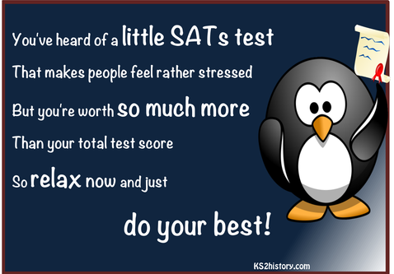
Year 6 SATs… What are they?
SATs (Standard Assessment Tests) are designed to evaluate your child’s progress throughout years 3-6 and to compare how your child achieves against other children of their age.

Who takes SATs?
Children in English schools take SATs in year 2 and in year 6. In year 2, children are tested in maths and English (reading and spelling, punctuation and grammar). These tests are generally carried out in a very informal way so your child's under as little pressure as possible. There's no time limit and they're often done in small groups.

In year 6, the SATs become more formal – they're taken in a formal setting within a time limit. There are tests in maths and English. A small sample of schools is also chosen to complete SATs in science too. We will let parents know if we are chosen to complete the science SATs.

Maths SATs
The maths test consists of three papers - one arithmetic paper of 30 minutes and two reasoning papers of 45 minutes each.

The arithmetic paper tests your child’s understanding of number along with mental and written calculation skills. Your child will need to know a range of number facts (such as their times tables). They're also tested on their knowledge of written methods of calculations (such as short division).
Papers two and three are reasoning tests. Your child will need to apply their mathematical knowledge to solve problems. This could mean buying things in a shop, adapting recipes for different numbers or calculating area and perimeter for tiling a floor. These test papers cover a broader area of maths, including geometry and statistics, as well as number knowledge and arithmetic.

English SATs
There are two tests for English – a reading paper, which lasts for one hour, and a Grammar, Punctuation and Spelling (SPaG) paper. The SPaG paper has two parts: a spelling paper and a grammar paper. There's no English writing test - teachers in school will assess your child's writing.

The SATs Year 6 Reading Paper
During the reading test, your child will usually have three different texts to read. These will be a mixture of fiction and non-fiction writing, including poetry.
Your child will answer questions which assess their comprehension and inference skills. Inference means they'll have to use a mixture of evidence from the text and their own reasoning skills.
The questions range from multiple choice answers to longer, written responses.
In school, your child will have done lots of practice questions so that they're familiar with answering the different types of questions against a set time.

The SATs Year 6 SPaG Paper
In the grammar, punctuation and spelling test, your child will need to show they understand a range of grammatical terms.
Examples of these terms could be relative pronouns (such as which, who, that) and conjunctions (but, and, because).
Your child will also show they can use punctuation (such as inverted commas for direct speech) and knowledge of the language used in context.
The questions in the SPaG paper could be multiple-choice, joining boxes, writing in a sentence or writing a short explanation.
Some questions may ask your child to insert punctuation correctly into a sentence or identify a section of a sentence.
For the spelling test, your child will need to spell twenty words by inserting them into a sentence in their answer booklets. After each sentence is read aloud, they'll have time to write the word before the next sentence is read out.

When do the SATs take place?
SATs are currently due to take place in the week commencing 8th May 2023. All schools throughout the country are doing the test at the same time. They begin on a Monday and usually finish on the Thursday in the same week. You will receive more information closer to the time about how this will be organised in our school.

I hope this guide helps answer some of the questions you may have. Please contact me if you have any further questions.

Mr Tuohy

